Computer Systems and Internet Technologies - COMP1589

JSON, XML & Fetch
Lab

SUMMARY
When building modern web experiences, and more importantly when working with remote data, it is important to be able to utilise modern formats and technologies into your web pages.
In this lab you will be looking at XML RSS feeds, JSON API’s and the JavaScript “fetch” API to build a dynamic asynchronous user interface. This will build upon your expertise in AJAX from our previous lab when working with XMLHTTP requests, the Fetch API helps simplify this for developers.

OBJECTIVES
- To develop a web application that will dynamically load and display data from a remote source
- To parse and output XML content from an RSS feed
- To parse and output JSON content from a remote endpoint

HTML Source
Before starting this lab, make sure you create a new HTML file and paste the base HTML code into it. You can get the HTML from the link below:
https://pastebin.com/7v1bYDjU
I’d strongly suggest that you first of all read through the code and ensure you understand it, and can run it in your browser. The code at this stage won’t do a lot, it is using Tailwind to style it.

TASK 1 - Fetch
The first thing we will be doing is implementing the JS Fetch API, you can learn more about this API and view documentation on it at Fetch API.
It massively simplifies the XMLHttpRequest approach when getting/fetching data from URLs, let’s take a look.
First of all you need to add your script tags to the end of your document, place these just before the closing body tag - something like below:
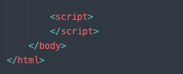
Now let’s add a basic fetch request and output the response to the console, make sure you have the browser console open during development so you can see what is happening.

const endpoint_url = 'https://api.spaceflightnewsapi.net'
fetch(endpoint_url)
.then(response => console.log(response))

Within the code we are defining a const variable to store the URL we wish to fetch, this makes it easier for us to update and reuse this code if need be.
Then we have our “fetch” API call, this is simply calling the “fetch” function and passing through the variable we just defined - the URL of the resource we wish to fetch. As fetch is an async, promise based, function we need to tell it what to do once the request is complete. For this we use the “then” chained method, and inside this we use the arrow function style to log the “response” to the console.
Now if you open your browser you should see it is making a request, in the “Network” panel and you should see the output in the console which is a 404 due to the URL we’re requesting being a dead end.
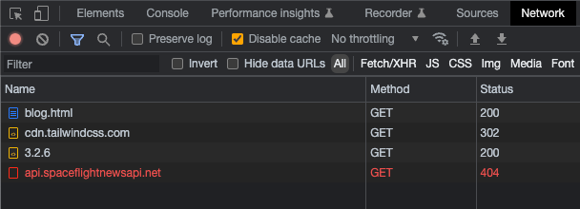
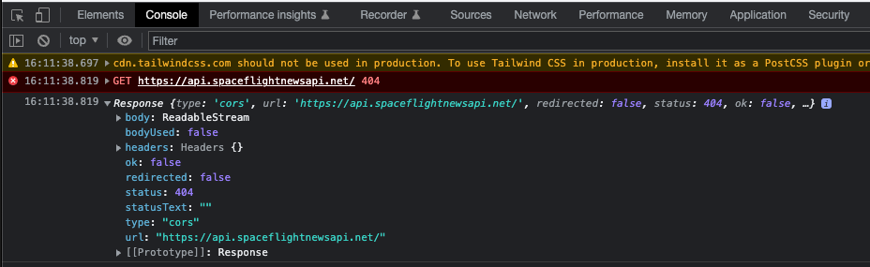
It’s as simple as that, we are making an AJAX request using just two lines of JavaScript.

TASK 2 - XML Digest & Output
Now the fetch API alone isn’t necessarily of much use, we often want to have our code digest some data from the resource and ideally output it in a friendly way for our users.
Let’s take a look at ingesting and parsing XML from an RSS feed, this a common format in software development and some APIs. RSS and XML are very common ways of digesting information from news outlets and blogs.
First of all let’s update our URL to the RSS feed we wish to digest, in this case we will take the New York Times technology news feed.
Update your endpoint_url to “https://rss.nytimes.com/services/xml/rss/nyt/Technology.xml”.
const endpoint_url = 'https://rss.nytimes.com/services/xml/rss/nyt/Technology.xml'
You should now see we no longer get an error in our fetch request within our browser, if you open the link in your browser you will see some code - formatted it looks like the below.
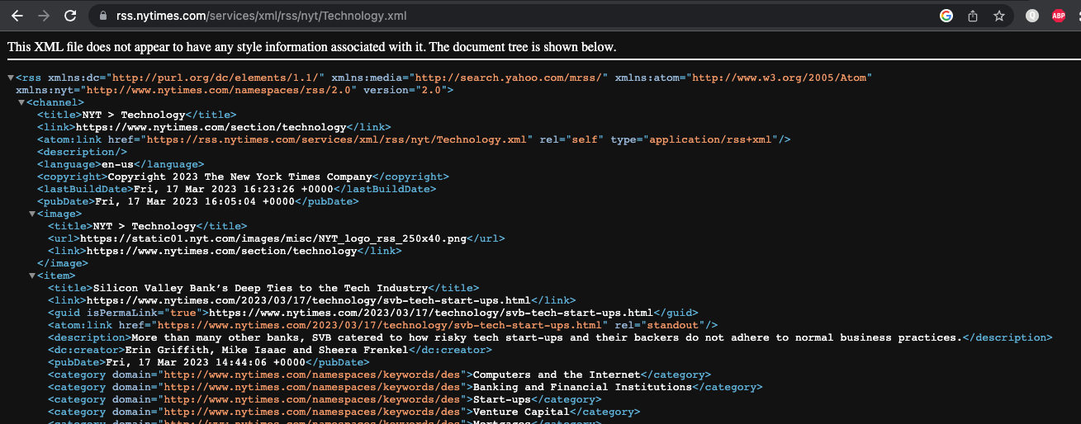
Now we need to “parse” this XML code to make sense of it and make it usable within our code, to do this we need to update our promise from the Fetch API to do a bit more work.
Replace your fetch method with the below code:
fetch(endpoint_url)
.then(response => response.text())
.then(str => new window.DOMParser().parseFromString(str, 'text/xml'))
In the above code we are first of all parsing the request response and converting it to plain text, this is so we can then read it as XML. This parsing, “response.text()” method returns another promise and therefore we can chain another method with the “then” method.
In our second promise we are taking the response text, in our “str” variable, and then loading that into our XML parser. Because XML is very similar to HTML, we can use a DOM Parser for this and simply tell it we are working with XML.
Running this code alone won’t show you anything as we have no console or browser output, so we need one more step to output our XML data. Let’s add another promise “then” chain, as the “parseFromString” method returns a promise.
You can see below we are sending the data once more, this time in the “data” variable and not to a larger function as we wish to do a bit more when processing this code.
fetch(endpoint_url)
.then(response => response.text())
.then(str => new window.DOMParser().parseFromString(str, 'text/xml'))
.then(data => {
console.log(data)
})
When you run this code in the console you should now see the XML document, similar to this:
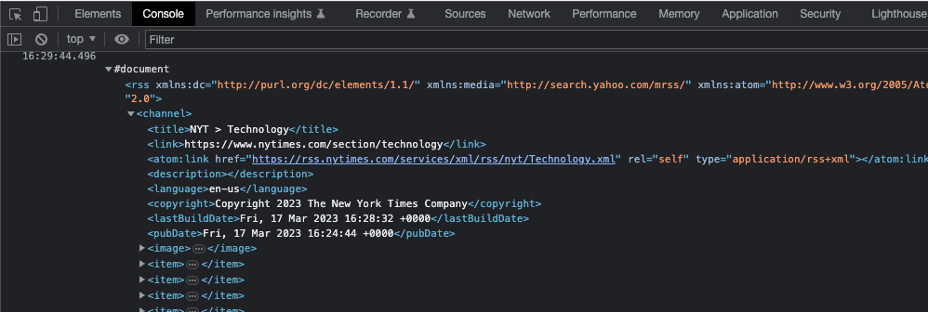
Now that we have our document ready for use we can start to build our display, to help speed things along please update your code to the below. Hopefully most of this makes sense, if not please ask us. I’ve added some explanations below the code to help make sense of the additions.
First of all add two new variables to the top of your script tag, this will allow us to interact with our loading icon and blog posts area later on.
const blog_posts = document.getElementById('blog-posts')
const loadingIndicator = document.getElementById('loading-indicator')
Now within the final chain “then” method, where we are using our “data” variable, let’s add some layout design.
data => {
const items = data.querySelectorAll('item')
let html = ``
items.forEach(el => {
const link = ''
const title = ''
const description = ''
const author = ''
const image = ''
html += `
<article class="flex flex-col items-start justify-between">
<div class="relative w-full">
<img src="" alt="" class="aspect-[16/9] w-full rounded-2xl bg-gray-100 object-cover sm:aspect-[2/1] lg:aspect-[3/2]">
<div class="absolute inset-0 rounded-2xl ring-1 ring-inset ring-gray-900/10"></div>
</div>
<div class="max-w-xl">
<div class="group relative">
<h3 class="mt-3 text-lg font-semibold leading-6 text-gray-900 group-hover:text-gray-600">
<a href="" target="_blank">
<span class="absolute inset-0"></span>
</a>
</h3>
<p class="mt-5 text-sm leading-6 text-gray-600 line-clamp-3">
</p>
</div>
<div class="relative mt-8 flex items-center gap-x-4">
<div class="text-sm leading-6">
<p class="font-semibold text-gray-900">
<a href="" target="_blank">
<span class="absolute inset-0"></span>
</a>
</p>
</div>
</div>
</div>
</article>
`
})
loadingIndicator.classList.add('hidden')
blog_posts.insertAdjacentHTML('beforeend', html)
})
In the first line of our updated code we are selecting the items from our XML document, this is a very similar approach to how we would use a query selector in HTML. We are selecting by the element name, so if you look at the XML file you will see many elements called “item”.
const items = data.querySelectorAll('item')
The line after this, and the lines towards the end of our document are what we use to hide the loading icon and output the page content. We first define our placeholder HTML variable, this is using template literals (backticks) rather than single/double quotes, this is a type of JS templating system which we will look at in a second - you can learn more about it at Template literals (Template strings) - JavaScript | MDN.
We then have a line to hide the loading icon using the CSS class “hidden”, this is applied once our remote source is loaded and content is ready for display. Finally we inject the contents of our HTML variable at the end of our blog post section of HTML.
let html = ``
/* ... */
loadingIndicator.classList.add('hidden')
blog_posts.insertAdjacentHTML('beforeend', html)
Our final piece of code is where we iterate/loop through our items from the RSS feed, we use the “forEach” method which is applicable to JavaScript arrays. We assign the value of each element to the “el” variable and define a block of code to run for each element.
items.forEach(el => {
/* ... */
})
Within this block we define placeholder variables for our various pieces of content, and we write our HTML for our blog post elements - you can see these output, without content, on the page if you reload it.
Now let’s assign some data to our variables, we will be using the content within the “item” in the XML feed.
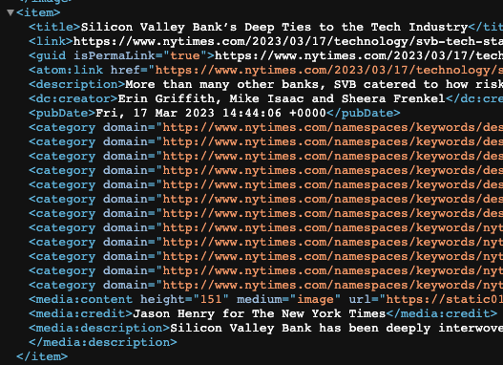
For the link, title and description we can use our query select to pick out these elements and get the content within them.
const link = el.querySelector('link').innerHTML
const title = el.querySelector('title').innerHTML
const description = el.querySelector('description').innerHTML
The author and image are a bit trickier as these are using a feature of XML known as namespacing, this is a concept across many programming languages. We can use a slightly different approach to get this content.
In the below code we are using the “getElementsByTagNameNS”, the “NS” at the end defines that we are using a namespace definition for this. At the top of our XML document you can see the various namespace definitions and their respective URLs.
const author = el.getElementsByTagNameNS('http://purl.org/dc/elements/1.1/', 'creator')[0]?.innerHTML
const image = el.getElementsByTagNameNS('http://search.yahoo.com/mrss/', 'content')[0]?.getAttribute('url')
First we need to identify the namespace from the XML and then place the URL inside the first argument of our function, then within our second argument we provide the attribute name (without the namespace, i.e. “media:content” becomes “content”).
Now because this is a pluralised method “getElements” we need to get the first instance of this, we only need this first one and don’t care if there are more. We can get this using the bracket accessor with the zero based index “[0]”.
Finally we use a null safe approach to access this element, the “?” in front of the dot selector “.” prevents the code from throwing an error if the element does not exist or is empty. We can then use our usual methods to retrieve content, innerHTML and getAttribute to retrieve a value from an attribute.
The final step is outputting this content to our page, using Template Literals we can easily update our HTML to include the variables we have now populated - the syntax is as below. We use the dollar symbol “$” with an opening and closing curly brackets “{“ and “}”.
`
<p class="mt-5 text-sm leading-6 text-gray-600 line-clamp-3">
${ description }
</p>
`
Go ahead and update your code to match the below, once you’ve done this if you reload your page it should display the blog posts.
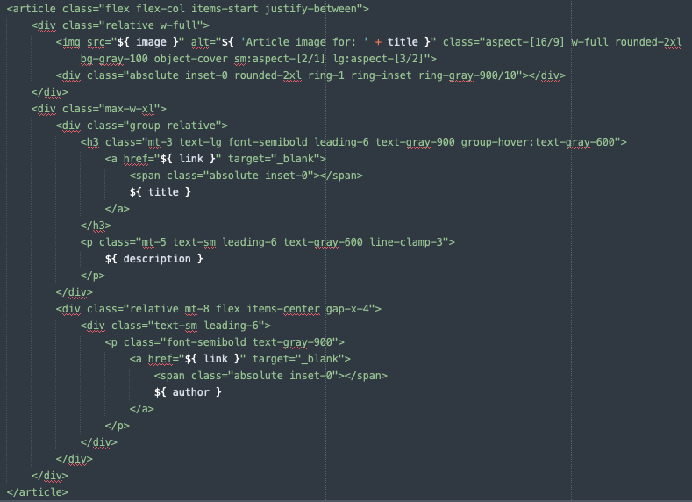
Your page should look something like this:
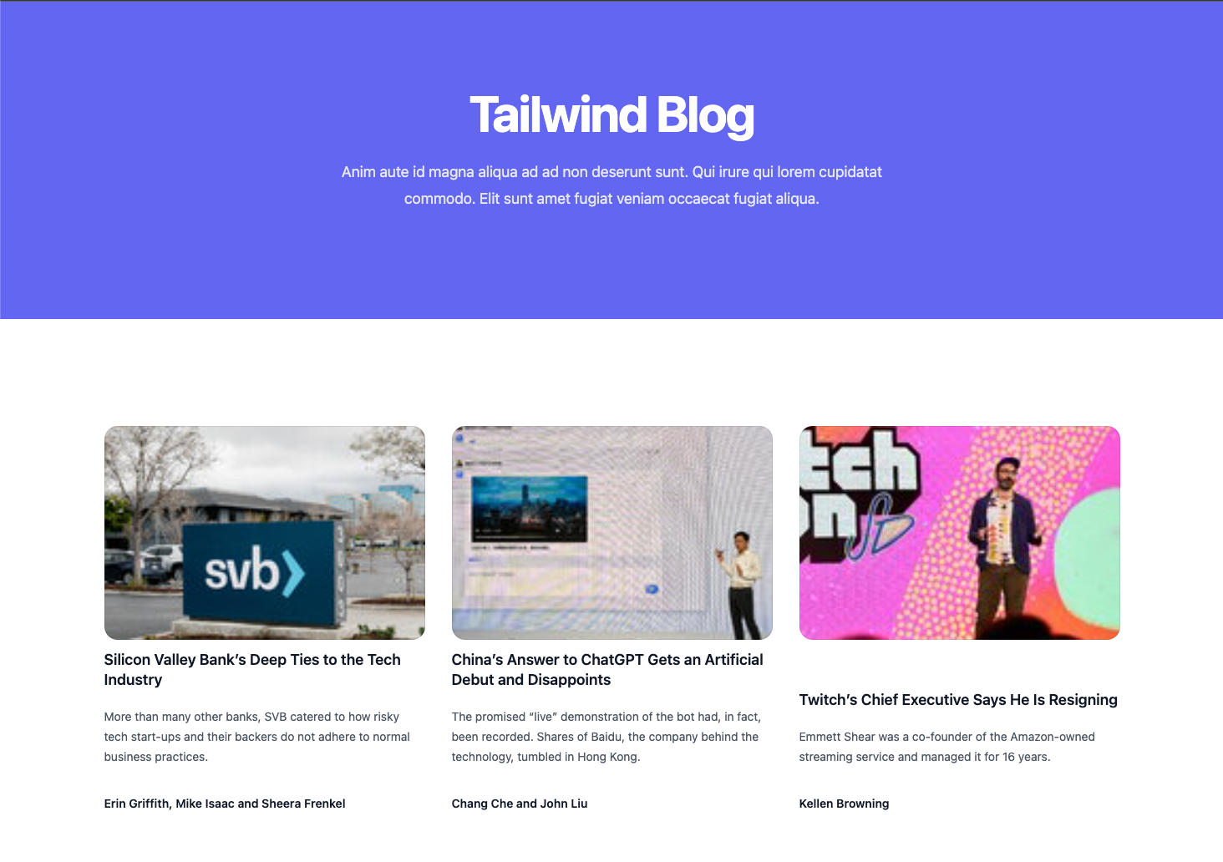

EXTRA TASK - JSON
If we wish to use JSON we can actually simplify our code slightly, let’s start by replacing our XML URL with a JSON one instead.
const endpoint_url = 'https://api.spaceflightnewsapi.net/v3/blogs'
Now because we are working with a native JS format we can tell our code to treat it as such, rather than as text update the below line:
.then(response => response.text())
To JSON:
.then(response => response.json())
Additionally we can delete our XML parser line entirely, delete the below line:
.then(str => new window.DOMParser().parseFromString(str, 'text/xml'))
As we are using a native JS format, we no longer need to select our elements from our response either, so we can delete the below line:
const items = data.querySelectorAll('item')
And we will now access our data directly, so change “items” to “data” on the below line:
/* change */
items.forEach(el => {
/* to */
data.forEach(el => {
Our final change is simply to our content mapping with our variables, we can simplify this to access our JSON properties directly. This is because they are now a JavaScript native object from our JSON file. Update your code to the below
const link = el.url
const title = el.title
const description = el.summary
const author = el.newsSite
const image = el.imageUrl

XML Code Solution
If you wish to compare your work to the desired outcome please see the final code solution at the below link:
https://pastebin.com/uZebWMtJ

JSON Code Solution
If you wish to compare your work to the desired outcome please see the final code solution at the below link:
https://pastebin.com/jzbP0z8b

